Midterm Revision - Coding Practice Exercises

**1.** (20 points) **Implementing a simple client-side JavaScript web application**

Using HTML, CSS and JavaScript, implement a mini-Banking web application, as shown in the UI screenshot below, with the following features and functionalities:

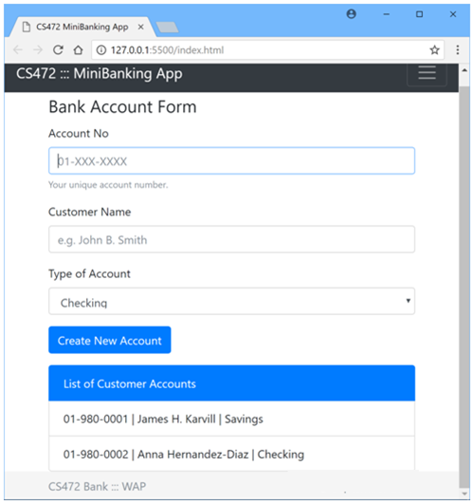

1. Code the User interface of the webapp using standards-compliant, semantically-correct HTML5 markup, including all the form fields as shown in the UI screenshot above.
2. Apply styling using Bootstrap or you may apply your own custom CSS styling to produce the same or similar look and layout. **Note:** Your UI does NOT necessarily have to be exactly the same as the sample shown above. But it should have all the necessary form data input fields, labels and buttons etc.
3. Account Number, Customer Name and Type of Account are all required, to create a new Bank account.
4. Add validation using appropriate regular expression to ensure that any Account Number entered must be in the specified format, 01-XXX-XXXX, as shown on the UI above. Where X is a numeric digit.
5. The user can create any one of three available types of Bank Accounts – Checking, Savings or Loan.
6. Using JQuery or plain-vanilla Javascript and DOM API, implement code to create New account and displaying the data at the bottom of the form, in the list control as shown in the UI screenshot above.